JOB DESCRIPTION

Job Title: Senior Philanthropy Manager
Location: Flexible working between home and office in Old Street, London
Contract type: Permanent
Accountable to: Head of Philanthropy and High Value Events
Line management: Philanthropy Manager
Salary: £45k pa (+ £5,023pa London Weighting if applicable)

Hours: 37.5 per week - flexible working and open to discussing reduced hours
Leave: 30 days holiday per annum plus bank holidays

About Shelter

Home is a human right. It's our foundation and it's where we thrive. Yet, every day millions of people struggle with homelessness, bad housing conditions, soaring rents, discrimination and the threat of eviction.

Shelter exists to defend the right to a safe home. We strive for change, with individuals, in communities, across society, and leading the way to a safe home. Above all we seek a transformation in housing policy, including investment in homes people on low incomes can actually afford – an investment that has been missing for decades, so that now the human cost has become intolerable.

We need ambitious, best-in-class individuals who are passionate about our cause to join us at this exciting time. This is your chance to help fund the fight for housing justice.

Why Join Shelter?

We welcome anyone to apply who possess the qualities and behaviours outlined or who believes they have the propensity to learn them fast. You will be joining an inclusive and supportive team who welcome people from all backgrounds. What’s important isn’t your level of education or the opportunities which you have had, it’s about you and how you seize the opportunities ahead of you.

We are happy to talk about flexible working, personal growth, and to promote a workplace where you can be yourself and achieve success based only on your merit. We also offer the following benefits:
- Flexible working hours
- Flexible working practices
- 30 days paid holiday plus bank holidays
- Competitive pension scheme
- Salary sacrifice schemes

Diversity Statement

At Shelter we are united by our purpose to defend the right to a safe home; our enemy is the social injustice at the core of the escalating housing emergency. We believe to win that fight; we must be representative of the people we are here to help and those who support our movement for change. In all our people decisions, we take pride in being inclusive, fair, equitable and transparent.

We have committed to combat racism both within and outside Shelter and welcome you on our journey to becoming a truly anti-racist organisation.

About the Team

The High Value Partnerships department is crucial to achieving Shelter’s charitable, raising over £20 million a year through relationship-based fundraising with high-net-worth individuals, legacy pledgers, trusts and major businesses. Sitting at the heart of the team is a special events programme, which acts as a platform for cultivation and stewardship of high value relationships.

Philanthropy Team

Support from individual philanthropists is vital to our work. The Philanthropy team work directly with high net worth individuals to raise new and uplifted major donor income, to help power Shelter’s work. We work 1:1 with major donors to match their needs, interests and philanthropic objectives with Shelter’s strategic aims. We provide tailored supporter journeys for all our major donor supporters, to connect them to the cause and recognise their impact and value. We have ambitious plans to significantly grow income to over £3 million a year and we are looking for a proactive Senior Philanthropy Manager to play a pivotal role in our success.

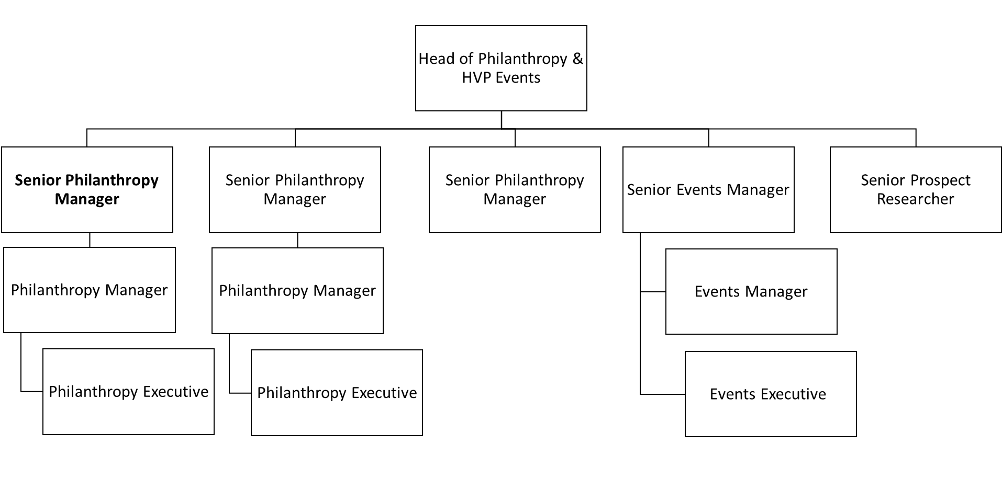
About the role

Over the last four years our philanthropy programme has doubled in size, with a solid foundation for this Senior Manager role to build on. You will split your time between managing a warm portfolio of donors giving five and six figure gifts, and building a pipeline of new major donor support at the £50k+ level.

You’ll be part of the wider Philanthropy and High Value Events team working to deliver world class supporter experience and bring our donors closer to our work than ever before, through creative proposals, excellent stewardship and engaging events.
You will be supported by an experienced, energetic fundraising team and colleagues in front line services, campaigns and finance. We have a strong frontline services and campaigning presence and there will be opportunities to meet with your service delivery and advocacy colleagues to learn more about Shelter’s work, so you are immersed and able to inspire donors to give.
This is a great opportunity to make a significant impact for the leading housing and homelessness organisation in the UK.

Role Specific Responsibilities

Cultivation and stewardship of relationships
- Maintain and uplift a small portfolio of existing high value major donor relationships by delivering a programme of excellent donor cultivation and stewardship, increasing levels of giving and exploring networks to extend our reach
- Develop strategically aligned and compelling funding propositions to inspire and uplift major donor support
Reaching new audiences
- Proactively build a pipeline of new major donor opportunities, by employing new acquisition strategies, with a focus on peer-to-peer approach
- Strengthen Shelter’s organisational culture of philanthropy to reach and engage new audiences, increasing collaboration with income generating teams as well as senior staff and volunteers
Leadership
- Support the Head of Philanthropy to implement the team strategy and agreed ways of working
- Proactively build strong relationships and seek opportunities for collaboration across High Value Partnerships and wider Shelter teams, to identify opportunities to maximise support
- Work closely with the Head of Philanthropy to inspire a culture of philanthropy at leadership and Board level
- Contribute to a culture of high performance by driving efficiency and sharing resources and knowledge
People management
- Give supportive and inspiring line management to a Philanthropy Manager, providing the leadership and space that allows them to thrive in role

About you

As part of a warm and motivated team, you will help us take philanthropy fundraising to new , growing income by maximising support from existing major donors and building a pipeline of new high-value opportunities.
To be successful in this role you will be a natural ‘go getter’ who is ambitious and determined, and is happy to be go the extra mile to provide first-class stewardship and win new support. You will be comfortable working in a fast-paced, ambitious environment with high expectations of work quality and output. You will be able to work independently and proactively, managing your own workload and making informed decisions regarding your supporters and projects.
You will have demonstrated experience in:
- Personally soliciting five and six figure donations from high net worth individuals
- Proactively identifying opportunities for new support at the £50k+ level, and seeing them through to delivery
- Working closely with leadership, senior volunteers and/or influencers to unlock peer connections and leverage new or uplifted support
- Effective management of complex projects with multiple stakeholders
- Developing and delivering engaging propositions and proposals which match supporter interests and philanthropic objectives with organisational priorities

Required behaviours

The Shelter Behaviours demonstrate the attitudes and approaches we take to our work; from how we do things, how we treat each other and expect to be treated both internally and externally. They help us to have the culture we need to deliver our ambitious strategy.
At Shelter we have 5 overall behaviours, that are each made up of 3 descriptors, these are outlined below.
We work together to achieve our shared purpose
- by actively collaborating and putting trust in the people we work with
- by recognising the contribution of others
- by carefully considering the “how” when taking on new projects and initiatives

We prioritise diversity and have an inclusive and open mindset
- by not tolerating and actively tackling racism and any other forms of hate and discrimination
- by creating safe spaces for people to be their authentic self, challenge each other and learn
- by being compassionate towards the people we work with and prioritising each other’s wellbeing

We enable decision making
- by giving people the tools, they need to make well informed decisions
- by being accountable for the decisions we make
- by delegating authority to those closest to the work

We create change and align behind our strategy
- by participating in change initiatives that deliver our strategy
- by supporting tough strategic choices
- by saying no to work that does not serve our purpose

We are open to risk and learning from our experiences
- by learning from our failures and successes
- by being reflective and giving and receiving feedback
- by being proactive and taking initiative

Other information

- All staff should adhere to Shelter's Equality Policy and will be expected to play a key role in its successful implementation.
- This post is not exempt from the Rehabilitation of Offenders Act.

Please note
This job description cannot cover every issue or task that may arise within the post at various times and the post-holder will be expected to carry out other duties from time to time which are broadly consistent with those in this document. This job description does not form part of the contract of employment.

TERMS & CONDITIONS SUMMARY

The following terms and conditions are typically offered to Shelter staff on fixed term and permanent contracts and are set out here or your information only. Terms and conditions may vary according to circumstances and this summary does not form part of any subsequent employment contract.

Probationary period: 6 months with a review at 3 months. During the first 3 months the contract may be terminated with 1 weeks’ notice, thereafter it will be 2 weeks up to the end of the probation period.

Annual Leave: 30 days annual leave and 8 bank holidays per annum (pro rata for part time staff and those working less than a year)

Pension: Contributory pension through AEGON, on condition the member of staff contributes at least 2%. Members of staff will be auto-enrolled in the pension on completion of three months employment.

From 1st April 2020 – employer’s contribution is 8%.

Life Assurance: 2 times your salary payable on death in service.

Sickness: 8 weeks full pay and 8 weeks half pay in the first year, on a sliding scale up to 24 weeks full pay and 24 weeks half pay after 4 years’ service.

Maternity/Adoption Leave: Statutory Maternity/Adoption pay, allowances and leave are available for people with less than 1 years’ service. After which time people will be entitled to Shelter’s enhanced arrangements.

Co-parental Leave: Up to 20 days paid leave (pro rata for part time staff).

Carers Leave: Up to 5 days paid leave per year for the care of sick dependants.

Season Ticket: A loan to purchase an annual season ticket for travel to and from work may be obtained with the agreement of your line manager. This is limited to £500 during the probation period.

Employee Assistance
Programme: Access to Shelter’s free personal support service

